Ph.D. COMMON ENTRANCE TEST

SUBJECT – CHEMISTRY
Roll No:
PART B
Duration: 60 minutes Maximum Marks: 50
Instructions:
- This entrance test question paper is not to be taken out of the examination hall
- Question paper consists of Section A and Section B
- Section A consists of 30 MCQs carrying 1 Mark each. Write the Alphabet of the correct answer in the space given.
- Section B consists of Descriptive questions carrying 5 marks each. Restrict your answer to 500 words. Additional plain sheets have been attached to the question paper to answer Section B

SECTION – A
Answer the following questions by writing the Alphabet of the correct answer in the Box given: 30 X 1 = 30
Which of the following cannot be obtained from X-ray diffraction studies
- Bond angle of Si-O-Si in a mineral
- Absolute configuration of a chiral natural product

- Vibration frequency of a carbonyl group
- Spacing between two parallel aromatic rings

Calculate the EMF of the cell $Ag\left(s\right)\left|{Ag}^{+}\left(aq, 0.010 M\right)\right||{Ag}^{+}\left(aq,1.0 M\right)|Ag(s)$
A. 0.0591 V
B. 100 V

C. 0.12 V
D. Cannot be determined with the data provided

According to the Grotthus Draper Law in photochemistry
- One molecule absorbs one quanta of light
- A radiation should be absorbed by the system to cause a photochemical reaction
- The quantum yield of a photochemical reaction can be more than one

- The energy of one mole of photons is an Einstein

Identify the wrong statement about LCAO
- Linear combination of a minimum of AOs are used to generate the MOs
- The number of MOs generated will be less than the total AOs used
- MOs are arranged from lowest to highest energy for filling

- MOs are filled following Hund’s rule and Pauli Exclusion
According to Pauling’s rules a radius ratio of 0.75 favors a coordination number of
- 8
- 6
- 4

- 12
δ bonds are formed between
- s-s orbitals
- s-p orbitals
- s-d orbitals

- d-d orbitals
The Born Landé equation relates
- Lattice energy to bond distance
- Bond order to valancy
- Enthalpy change to number of cycles

- Bond length to structure
Born-Oppenheimer approximation allows the separation of
- Rotational energy from translational energy of molecules
- Energy of the nucleus from that of electrons
- Energy of sigma and pi electrons

- Energy of core electrons and valance electrons
The phenomenon where two expected strong and weak bands are replaced with two strong bands in a vibrational spectrum is called
- Fundamental vibration
- Overtone

- Combination band
- Fermi Resonance
The chromatographic analysis for a compound gave a retention time of 8 min and a baseline width of 0.2 in a column 2 m long. What is the height of a theoretical plate in mm?
- 4
- 1.25

- 2.5
- 5
The allotrope of carbon that is a 2D nanomaterial is
- Carbon nanotube
- Fullerene
- Graphene

- Graphite
Nylon 6 is
- Polyacrylamide
- Polycaprolactam
- Polystyrene

- Polyethylene
Quantum yield (Φ) is defined as
- the ratio of the number of electrons absorbed to the number of photons emitted
- the ratio of the number of photons emitted to the number of photons absorbed
- the ratio of the number of photons absorbed to the number of photons emitted

- the ratio of the number of photons absorbed to the number of absorbed electrons emitted
Addition of hydrogen halides is an example of ____________reactions of alkenes
- nucleophilic addition
- free radical addition
- electrophilic addition

- none of the above

Retrosynthesis of acetophenone gives two synthetic equivalents, which are…
- benzene and acetyl chloride
- phenol and acetyl chloride

- toluene and acetyl chloride
- benzene and methyl chloride
The most deshielded proton among the options is
- C₆H₅--H
- C=C--H
- C≡C—H

- All are shielded
For a rotational vibrational transition the true statement is
- Rotational and vibrational quantum numbers should change
- Only rotational quantum number should change
- Only vibrational quantum number should change

- Any one need to change
The luminescence phenomenon with the highest lifetime is
- Phosphorescence
- Fluorescence
- Chemiluminescence

- Electroluminescence
In a solution, containing KCl and KI precipitation titration was carried out using standard silver nitrate solution. The precipitate formed at the initiation of the titration is ………. Ksp of AgI is 8.5x10⁻¹⁷ and that of AgCl is 1.7 x10⁻¹⁰
- KI
- KCl
- Both

- Depend on the concentration of silver nitrate solution

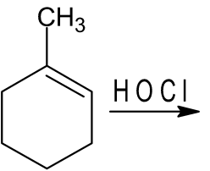

- 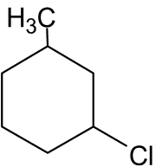
- 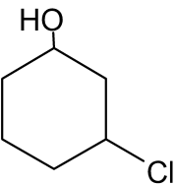

- 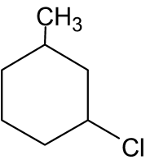

- 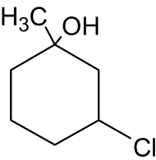

The metal in chlorophyll is
- Fe
- Mn
- Zn

- Mg

The Phosphorous isotope with a nuclear spin of ½ is
- ³⁰P
- ³¹P
- ³²P

- ³⁴P

The number of distinct protons in the NMR spectrum of ethanol is
- 1
- 2
- 3

- 4

The coordination number of an octahedral void site is
- 2
- 4
- 6

- 8

The method that can be used to prepare nanoparticles
- Sol-gel
- CVD
- Laser ablation

- All of the above

The colloidal system where a discontinuous solid phase is dispersed in a continuous liquid phase is
- sol
- gel
- aerogel

- aerosol
The reaction involving a carbanion is
- Claisen condensation
- Aldol condensation

- Dieckman condensation
- All of the above
The element with the highest electronegativity is
- Chlorine
- Oxygen

- Fluorine
- Carbon
The spectroscopic technique that can be used for characterizing a nanoparticle is
- ESR
- Absorbance spectroscopy

- Microwave spectroscopy
- None of the above
The radiation with the lowest energy in the list is
- Microwave
- Radio Waves

- X-rays
- Infra red

Section - B
Answer any four questions (Each question carry 5 marks 4*5 = 20

1. Explain the SN1 and SN2 mechanism of substitution reaction with an example

2. Discuss the use of X-ray diffraction in material characterization
3. Write a note on an electrochemical cell

4. Write a note on the use of various spectroscopies in the identification of molecules

5. What are nanomaterials? What are their uses?

6. What are the applications of polymers?

*********

